**UNEARTHING THE ENVIRONMENT IMPACT OF HUMAN ACTIVITIES : A GLOBAL CO2 EMISSION ANALYSIS**

A PROJECT REPORT

Submitted by

EZHILARASHU S 20203131517109

ABARNA V 20203131517101

LAVANYA R 20203131517111

PUSHPA KUMARI K 20203131517116

IN PARTIAL FULFILLMENT FOR THE AWARD OF THE DEGREE

OF

BACHELOR OF SCIENCE

IN

MATHEMATICS



PIONEER KUMARASWAMY COLLEGE

NAGERCOIL-629 003

MANONMANIAM SUNDARANAR UNIVERSITY

TIRUNELVELI-627 012

APRIL-2023

**CONTENTS**

1. INTRODUCTION

1.1. OVERVIEW

1.2. PURPOSE

2. PROBLEM DEFINITION & DESIGN THINKING

2.1. EMPATHY MAP

2.2. IDEATION & BRAINSTORMING MAP

3. RESULT

4. ADVANTAGES & DISADVANTAGES

5. APPLICATIONS

6. CONCLUSION

7. FUTURE SCOPE

1. **INTRODUCTION**

* 1. **Overview**

Human activities have a significant impact on the environment, and one of the most prominent contributors to this impact is carbon dioxide (CO2) emissions. CO2 is a greenhouse gas that is released into the atmosphere as a result of various human activities, including the burning of fossil fuels, deforestation, and industrial processes.

According to the Global Carbon Project, in 2020, global CO2 emissions from fossil fuel combustion and industrial processes were around 34 billion metric tons. This was a decrease of approximately 6.4% compared to 2019, largely due to the COVID-19 pandemic's impact on global economies and travel.

China is the largest emitter of CO2, accounting for approximately 28% of global emissions in 2020. The United States is the second-largest emitter, accounting for around 14% of global emissions, followed by India (7%), Russia (5%), and Japan (3%). Together, these five countries account for approximately 57% of global CO2 emissions.

The burning of fossil fuels for energy is the primary source of global CO2 emissions, accounting for approximately 85% of total emissions. Other significant sources include land-use change and forestry (10%) and industrial processes (5%).

The impact of these CO2 emissions on the environment is well-documented. CO2 and other greenhouse gases trap heat in the atmosphere, leading to a warming of the planet and changes in weather patterns, including more frequent and severe extreme weather events. This, in turn, can lead to a range of environmental and social impacts, including sea-level rise, more frequent and intense heatwaves, changes in precipitation patterns, and increased risk of droughts and wildfires.

To mitigate the impact of CO2 emissions, countries and companies around the world are taking action to reduce emissions through a variety of measures, including transitioning to renewable energy sources, improving energy efficiency, and implementing carbon capture and storage technologies. However, much more action is needed to achieve the necessary emissions reductions to limit the worst impacts of climate change.

* 1. **PURPOSE**

The purpose of conducting a global CO2 emissions analysis is to better understand the environmental impact of human activities, particularly the release of greenhouse gases into the atmosphere. Carbon dioxide is one of the most significant greenhouse gases, and human activities such as burning fossil fuels for energy, deforestation, and transportation contribute to the accumulation of CO2 in the atmosphere.

By analyzing global CO2 emissions data, researchers can identify patterns and trends in emissions, as well as the geographic distribution of emissions sources. This information can be used to develop policies and strategies for reducing greenhouse gas emissions and mitigating the effects of climate change.

Additionally, a global CO2 emissions analysis can help raise public awareness about the environmental impact of human activities and encourage individuals and organizations to take action to reduce their carbon footprint. By promoting sustainable practices and advocating for policies that prioritize environmental protection, we can work towards a more sustainable future for ourselves and future generations.

1. **PROBLEM DEFINITION & DESIGN THINKING :**

* 1. **EMPATHY MAP**

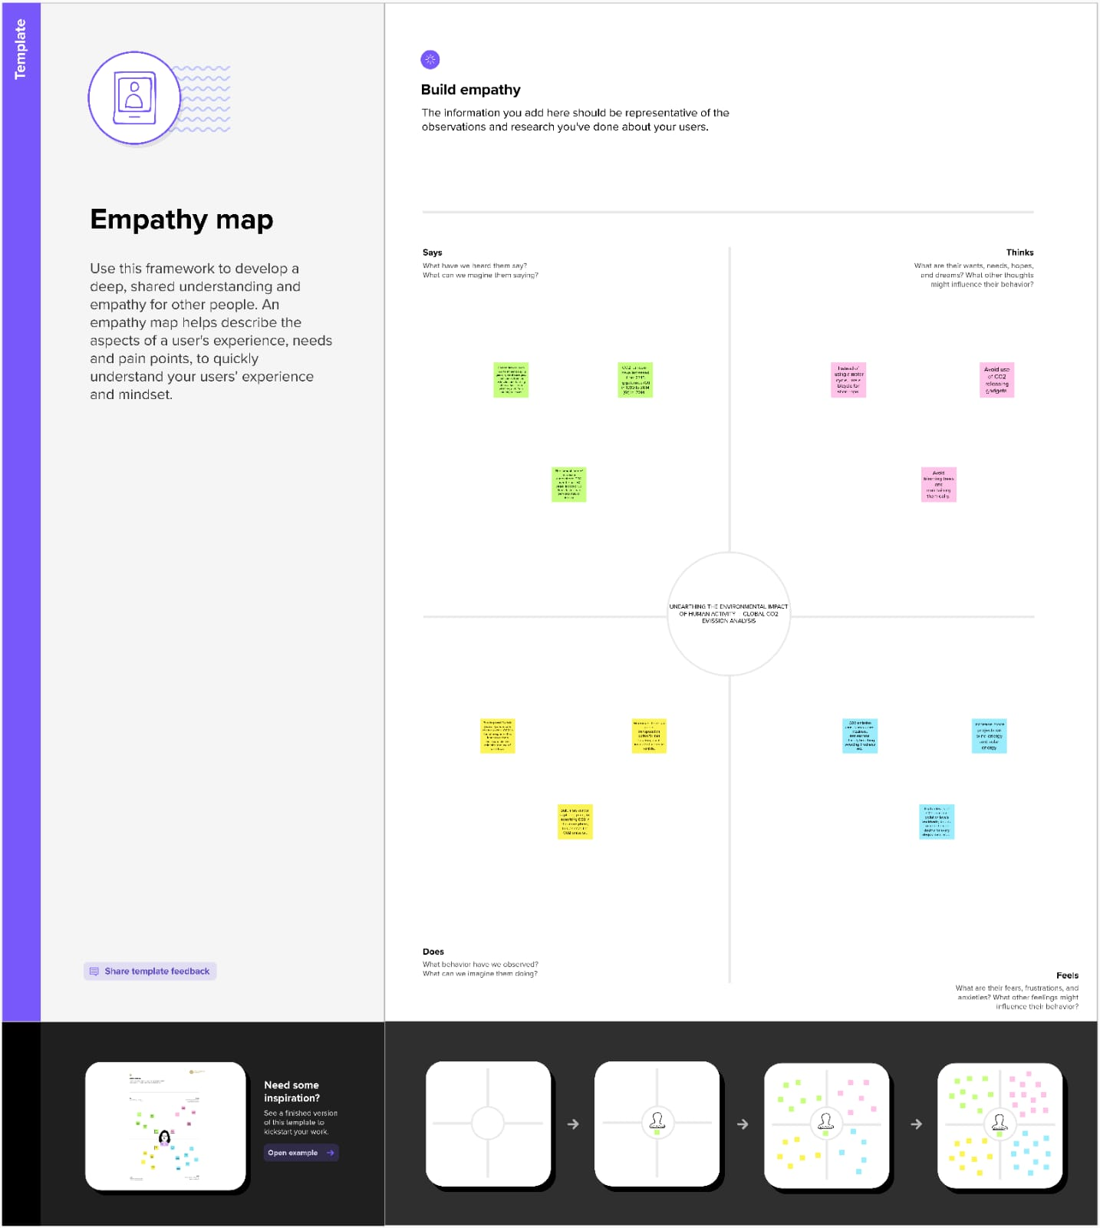

* 1. **IDEATION & BRAINSTORMING MAP**

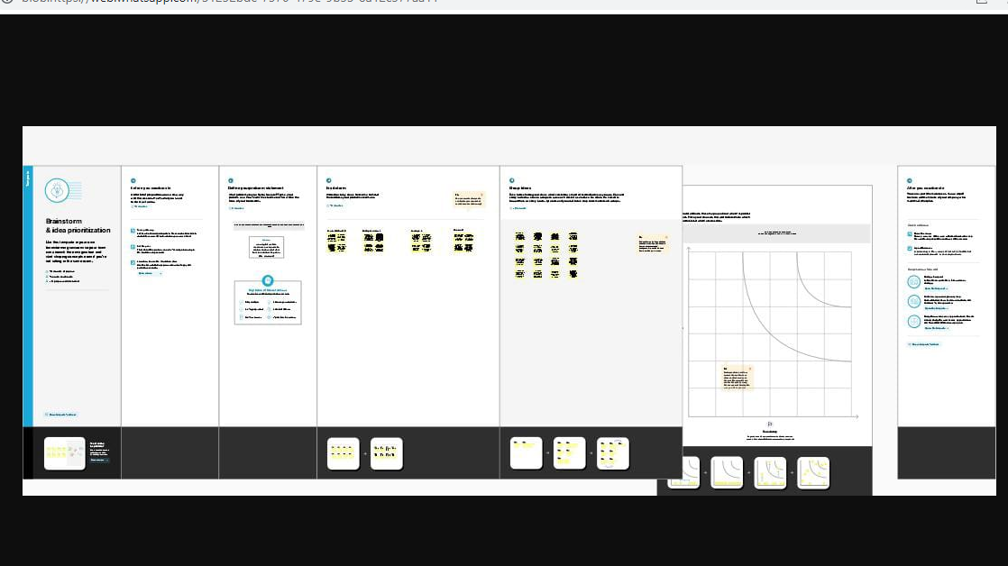

1. **RESULT :**

VISUALIZATION **:**

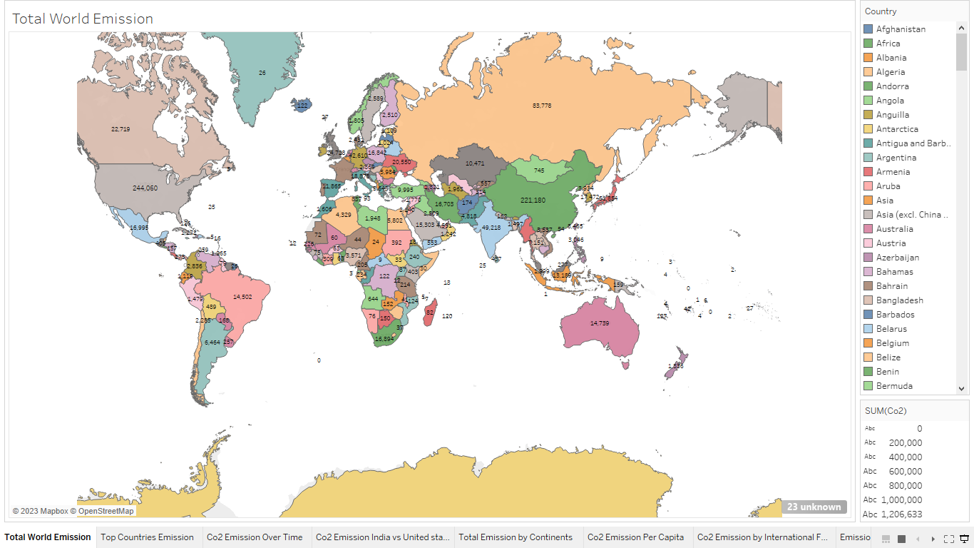

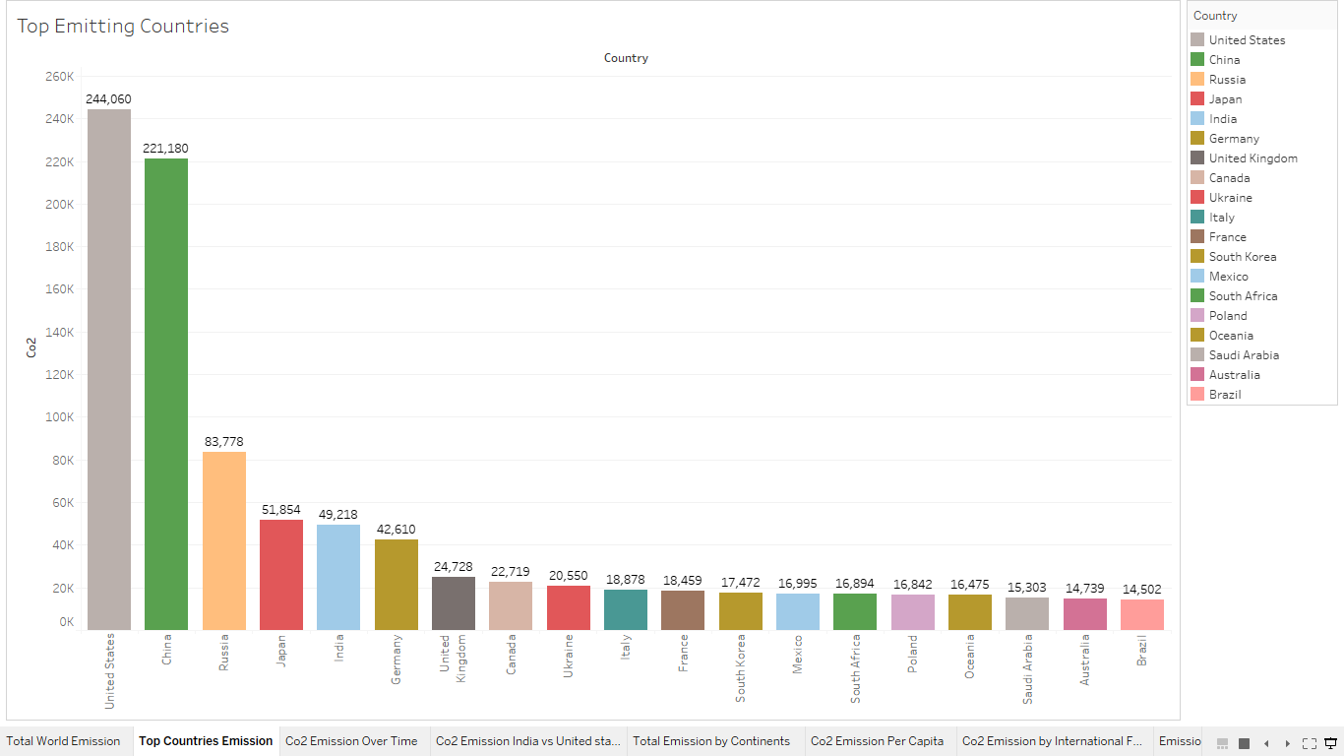

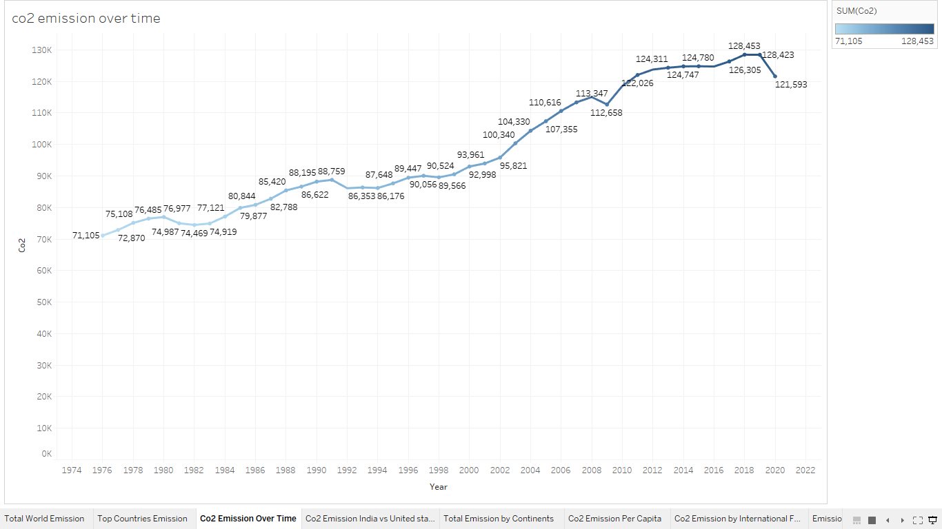

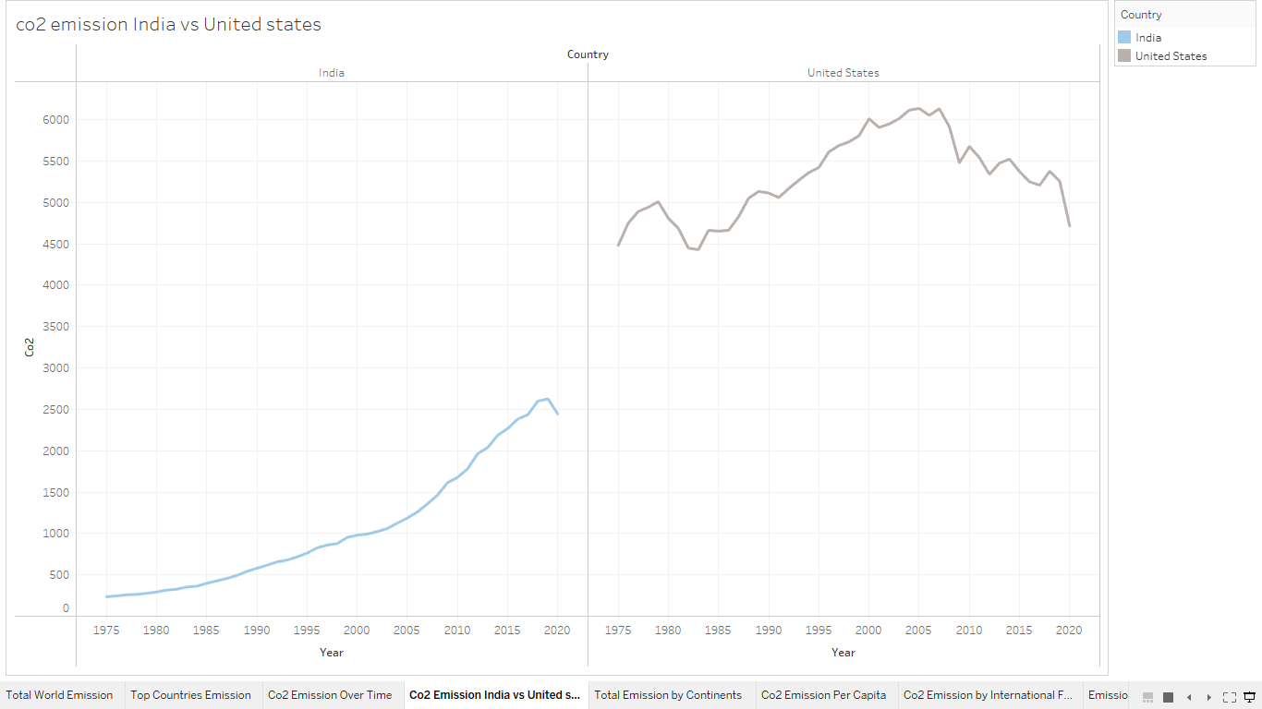

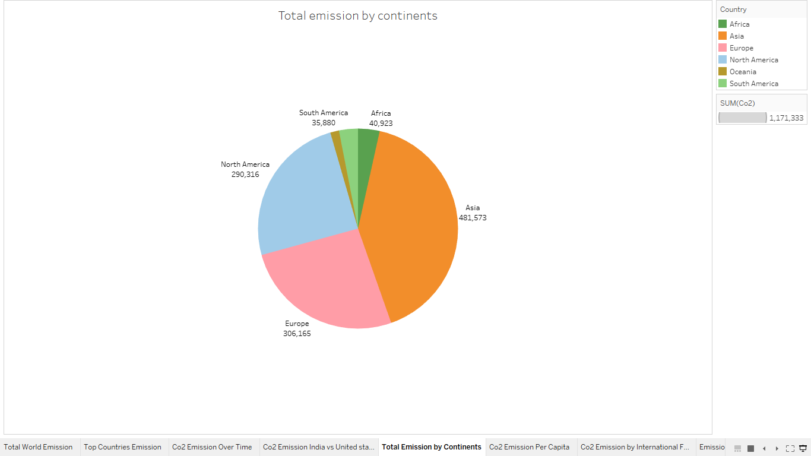

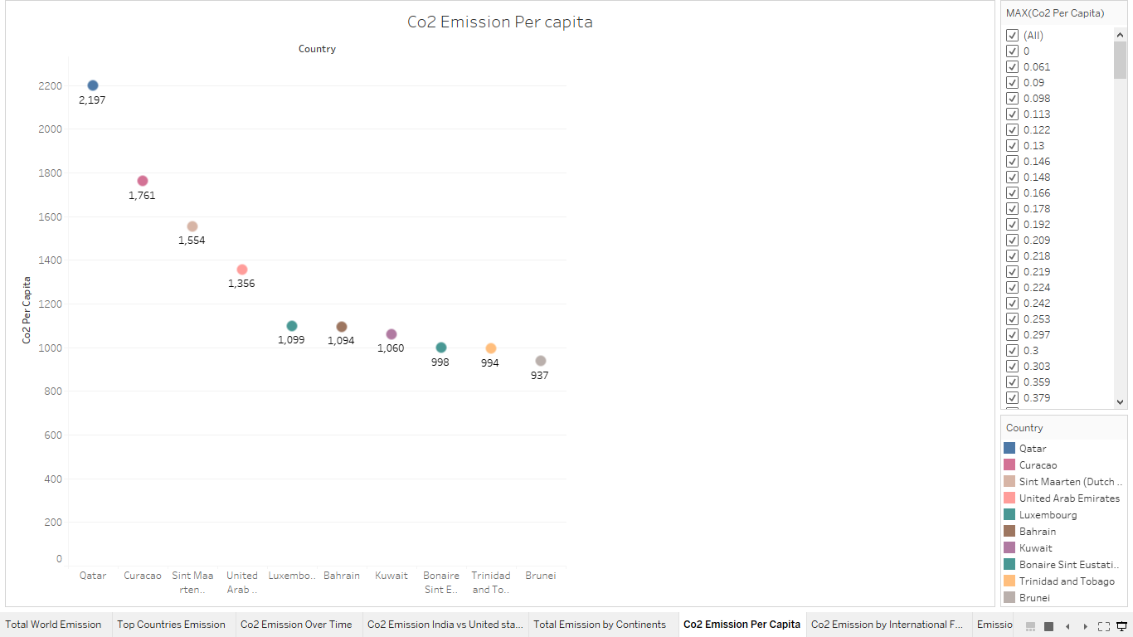

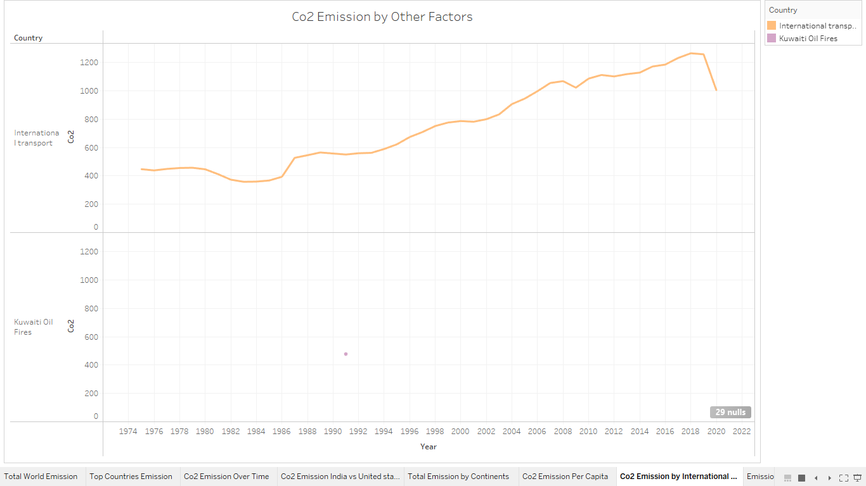

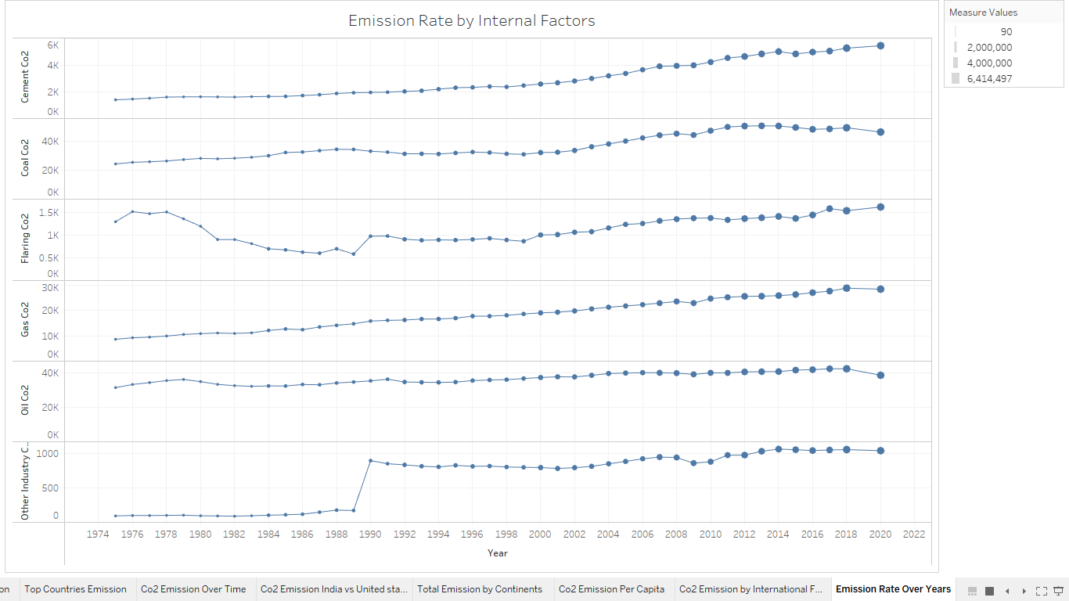

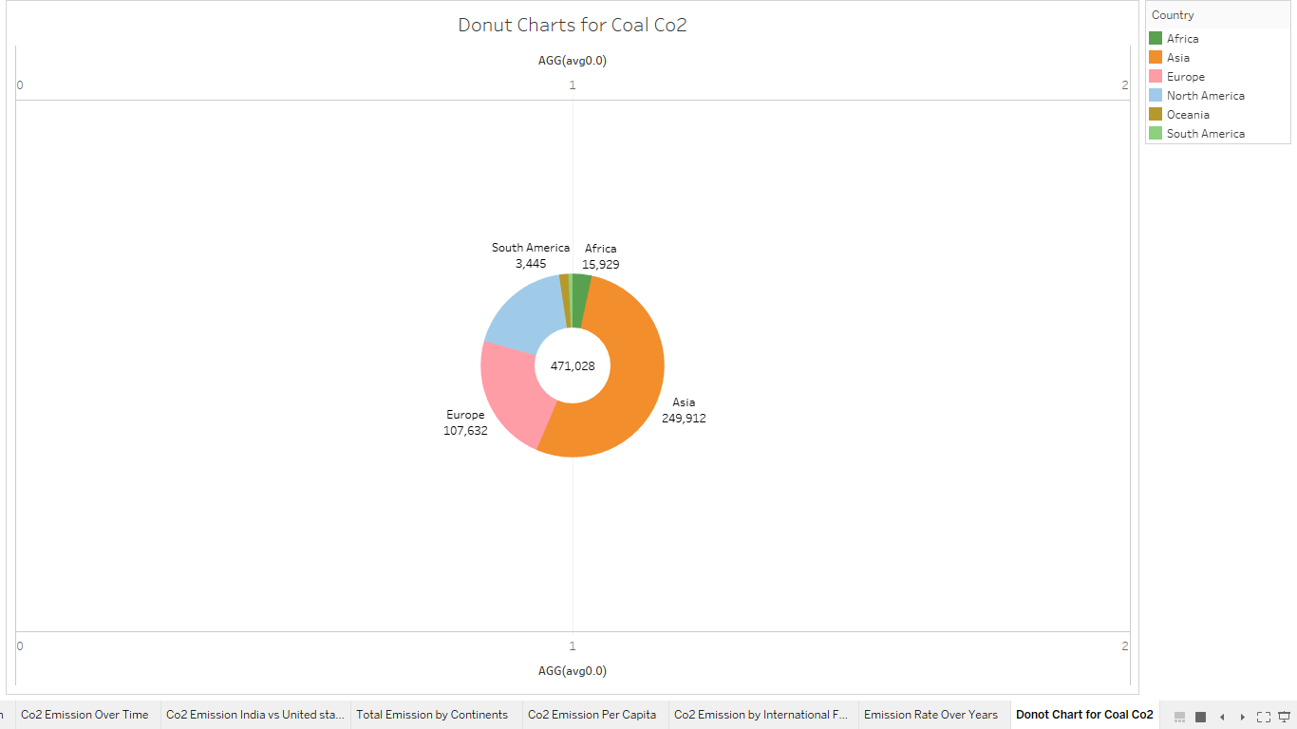

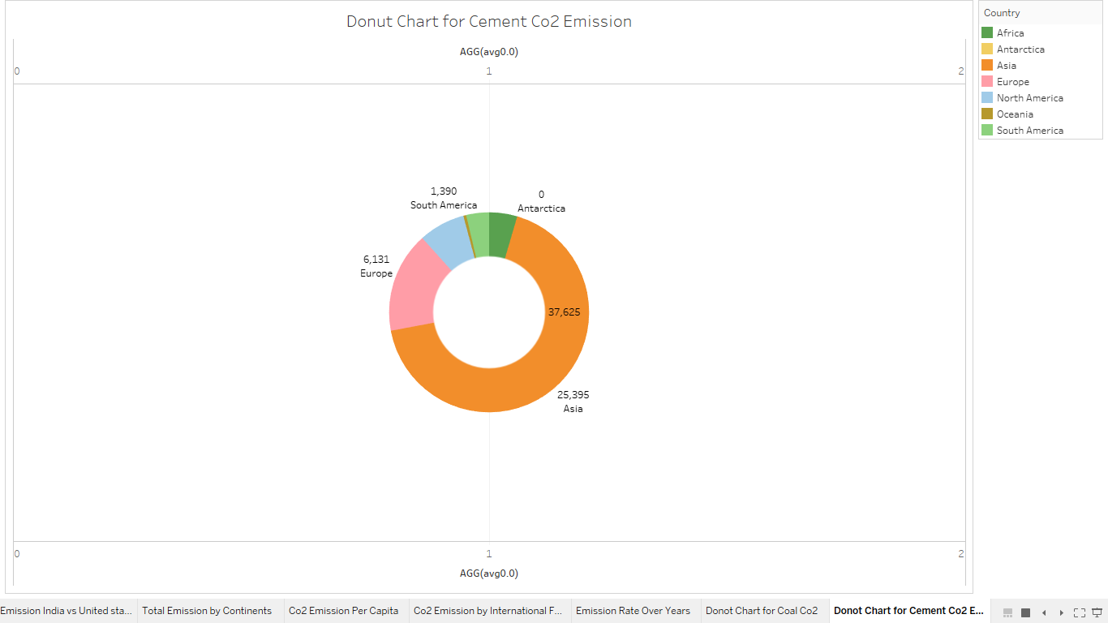

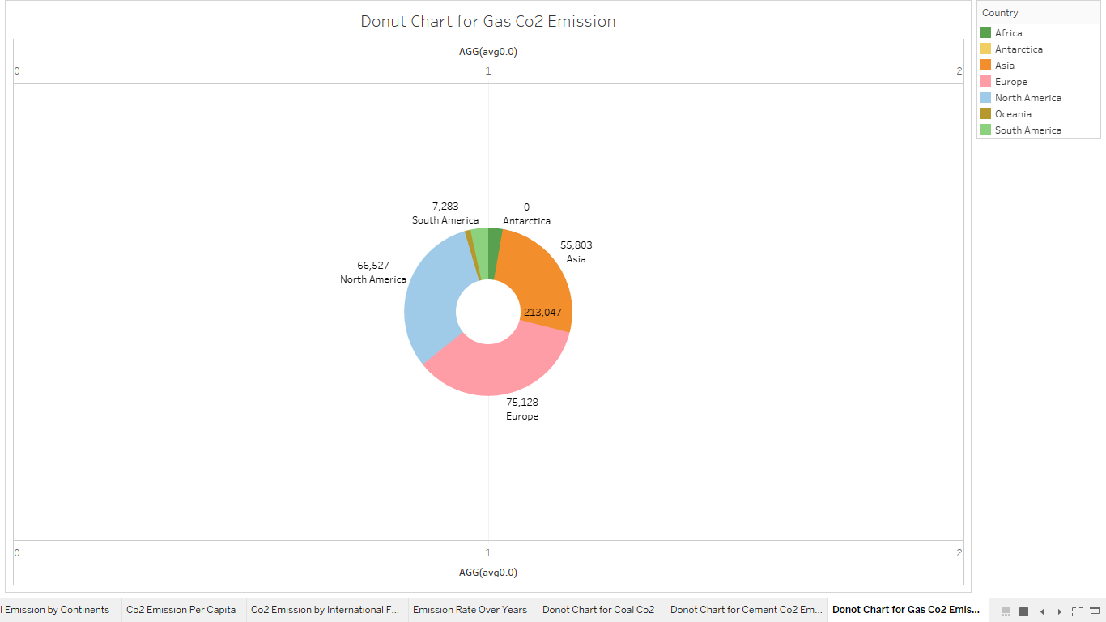

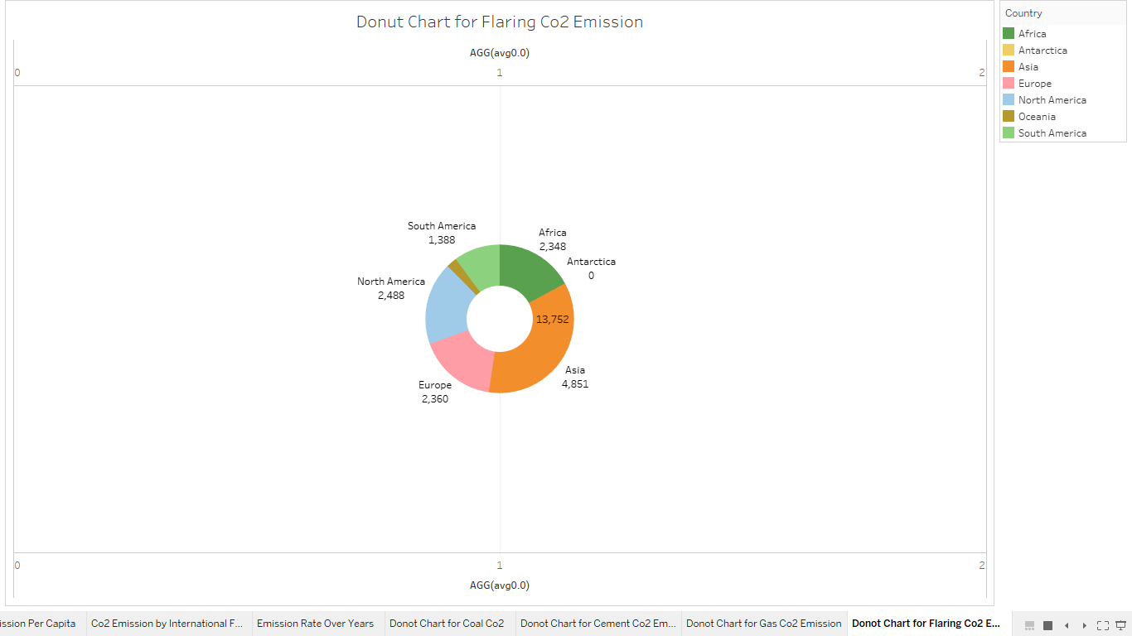

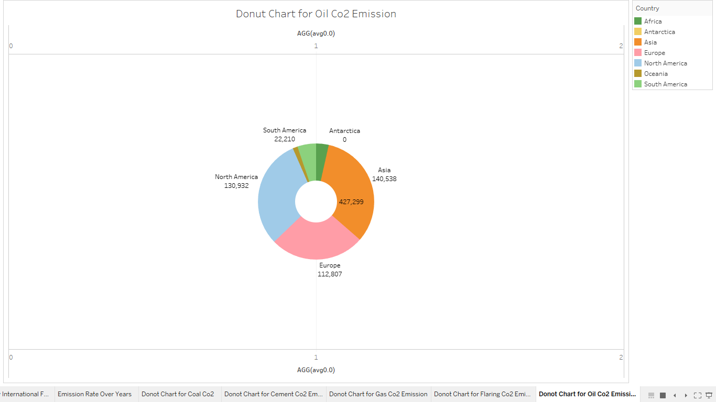

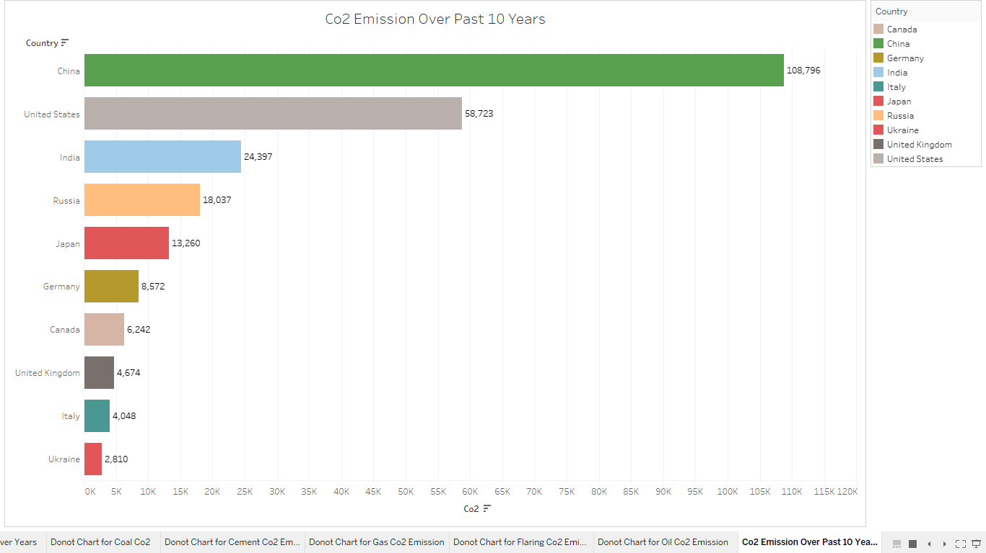

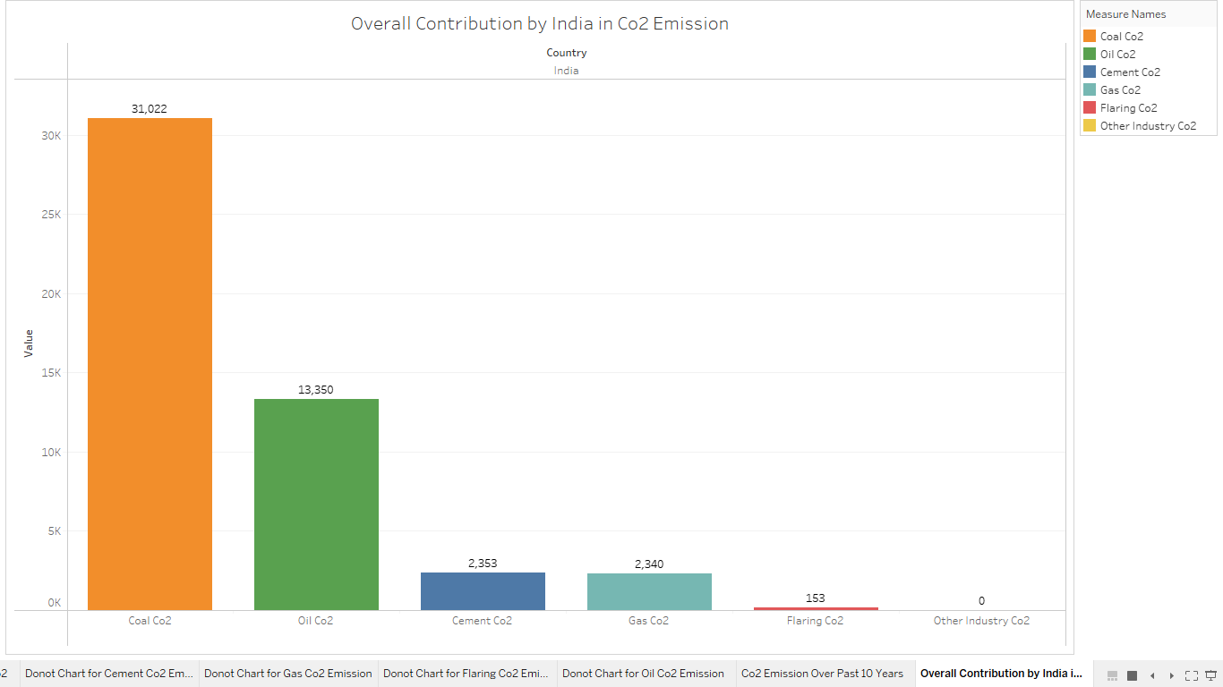

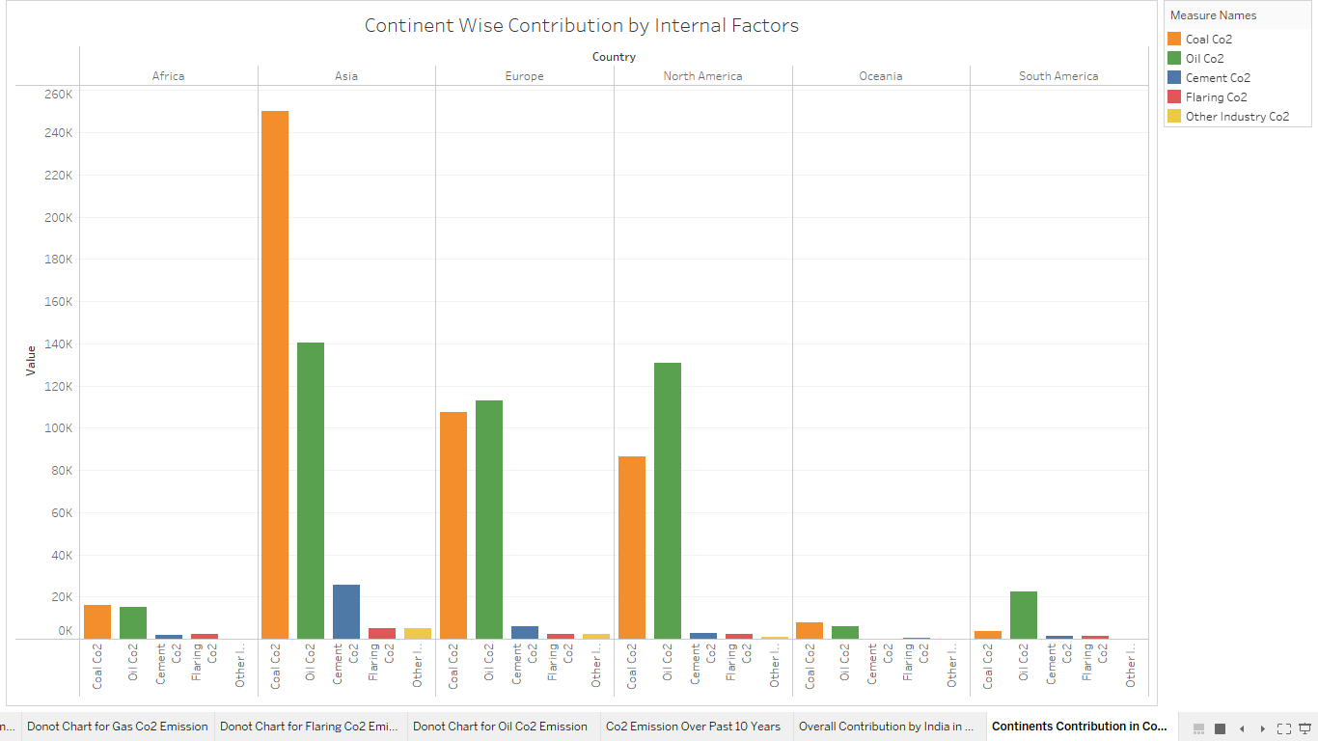

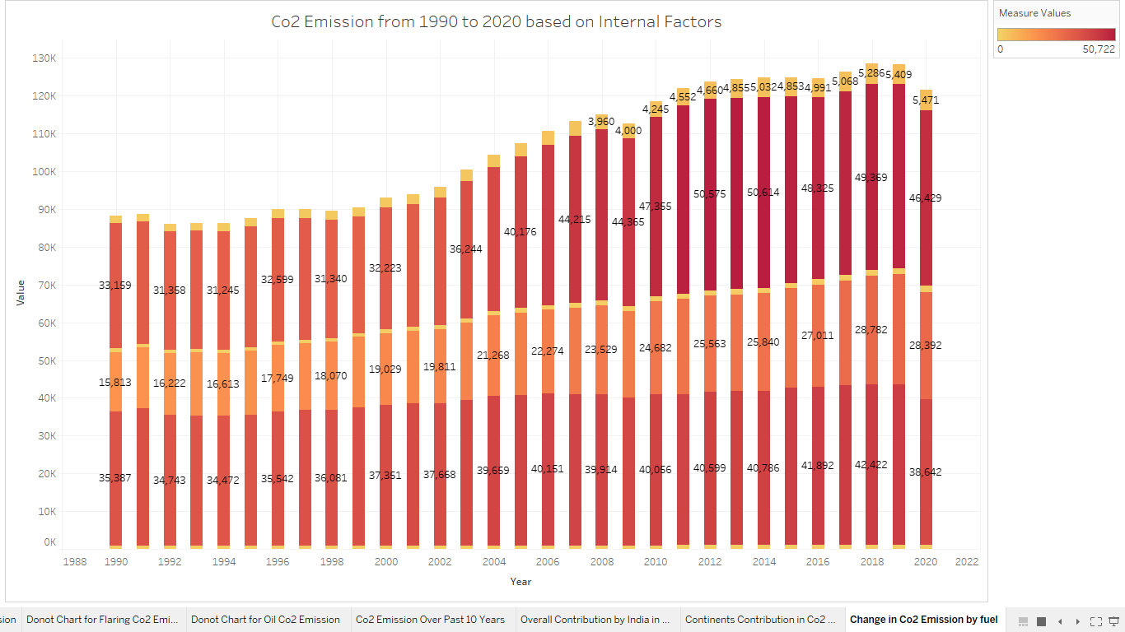

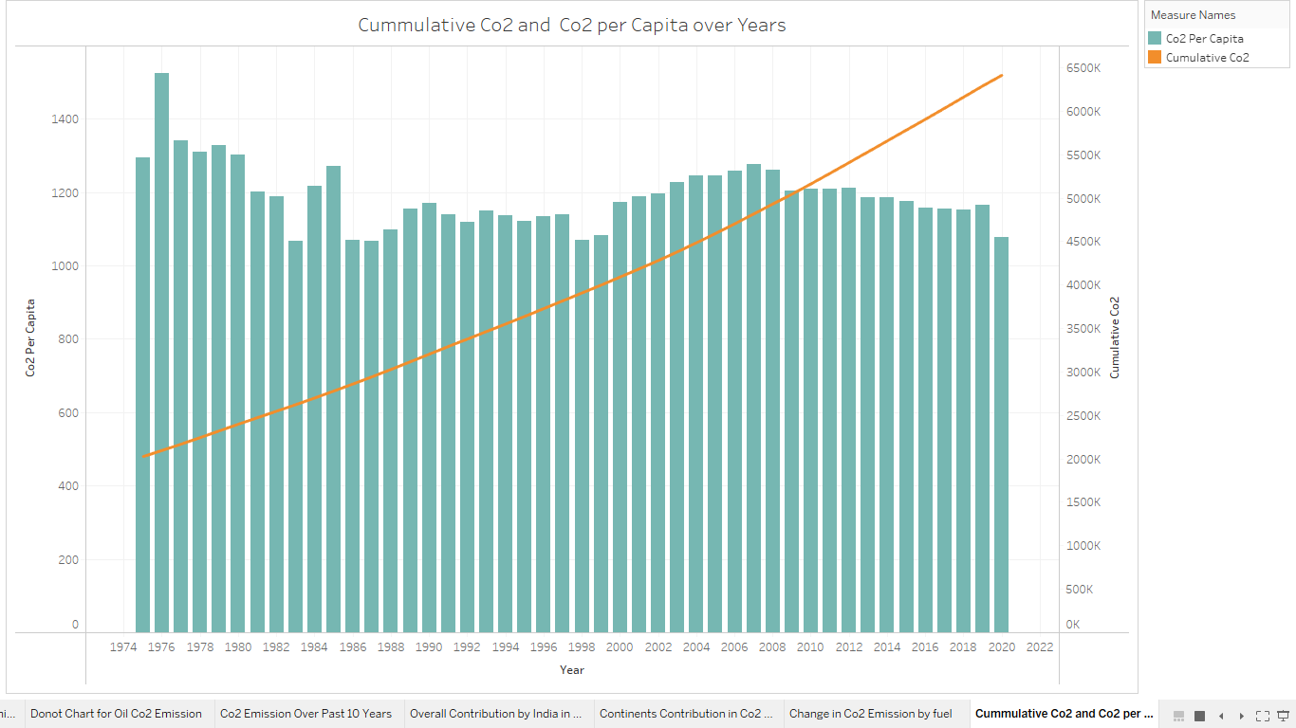

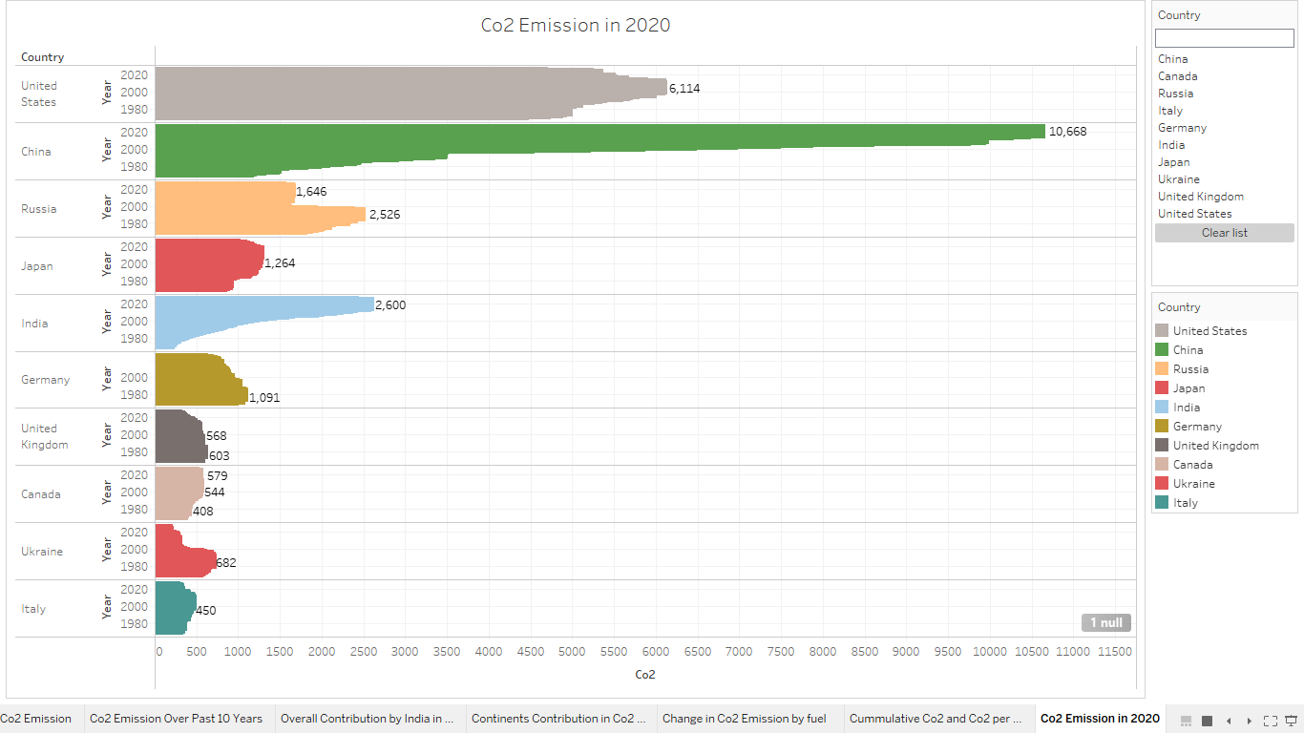

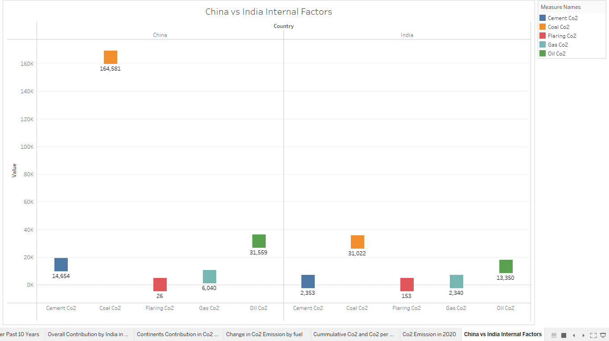

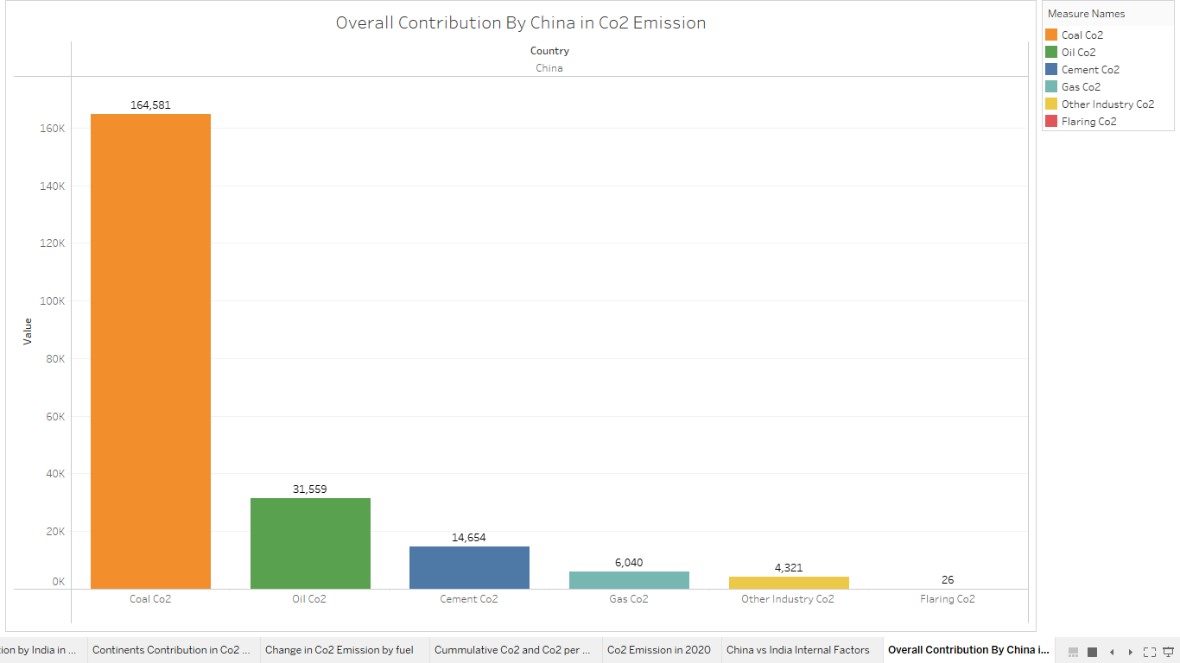

**DASHBOARD :**

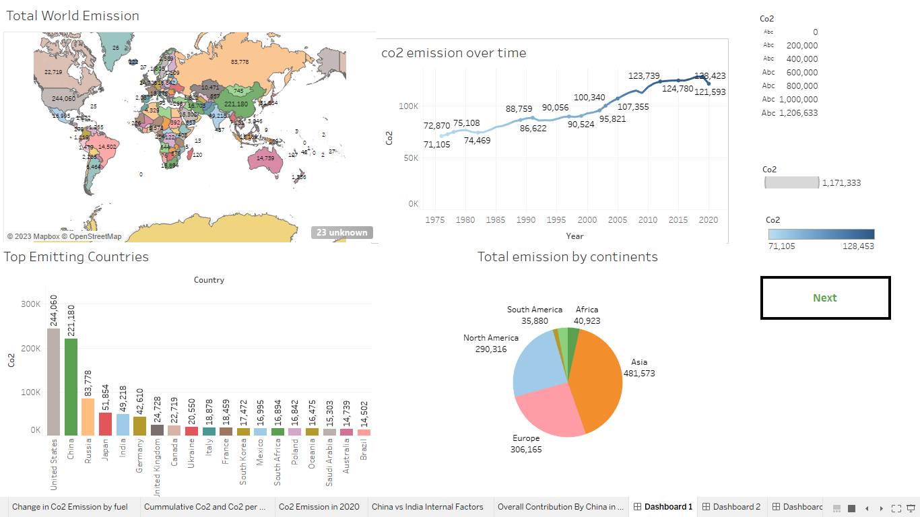

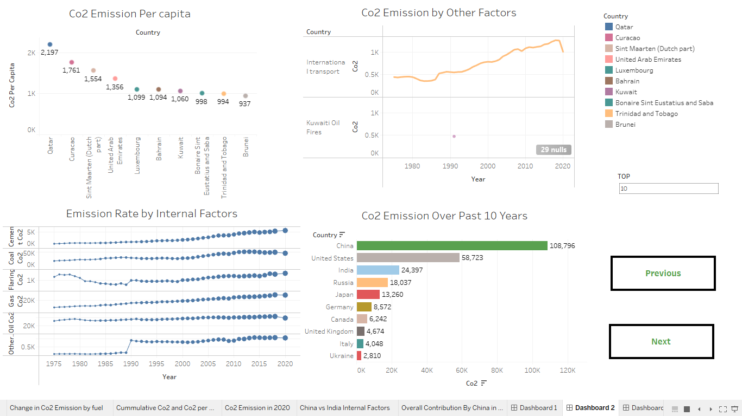

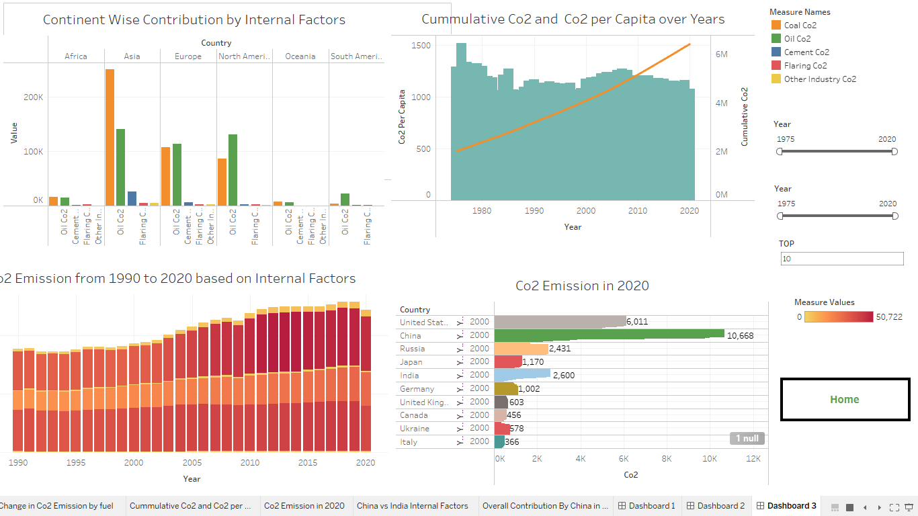

**STORY :**

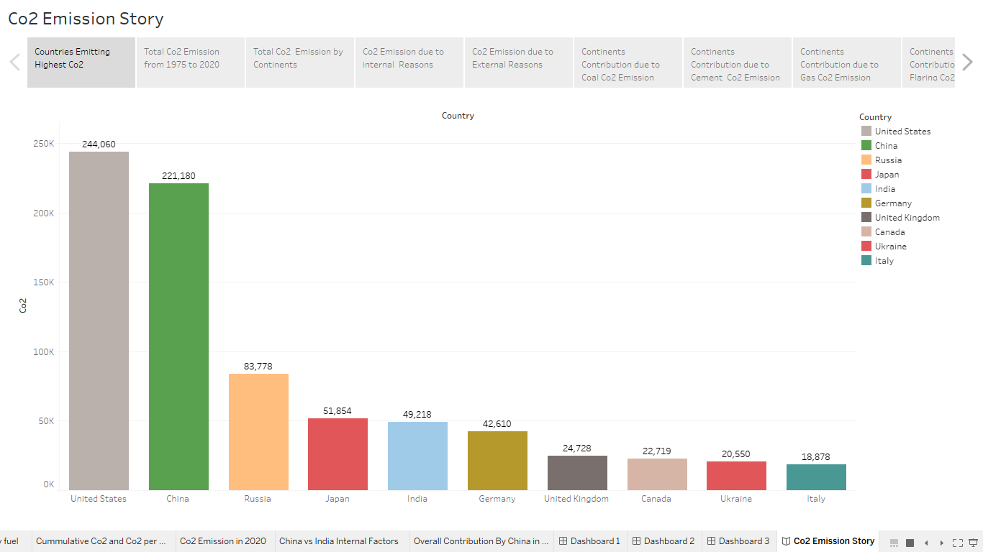

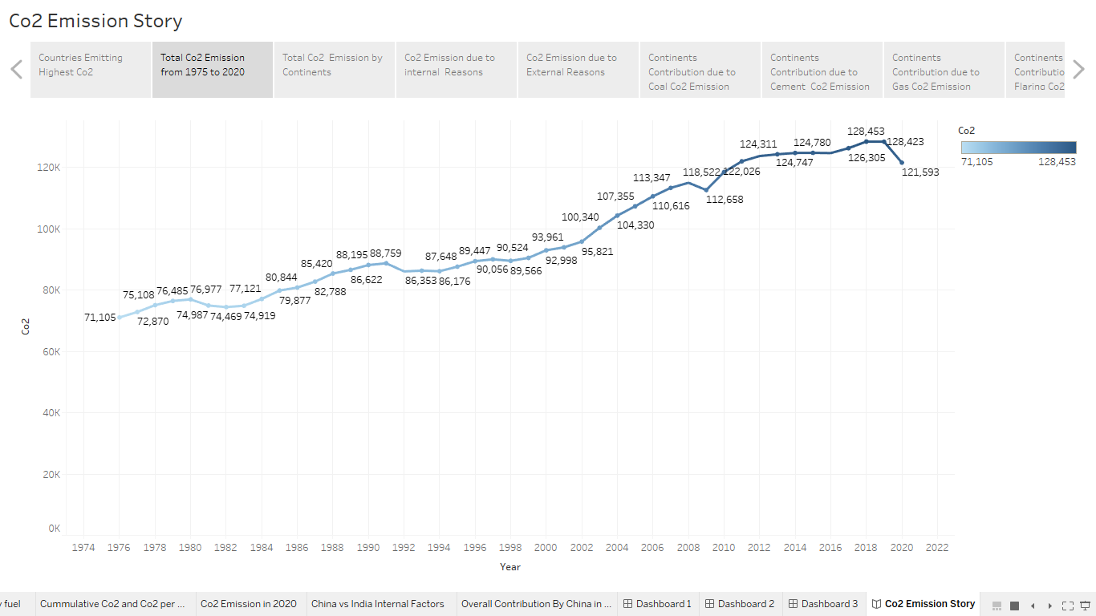

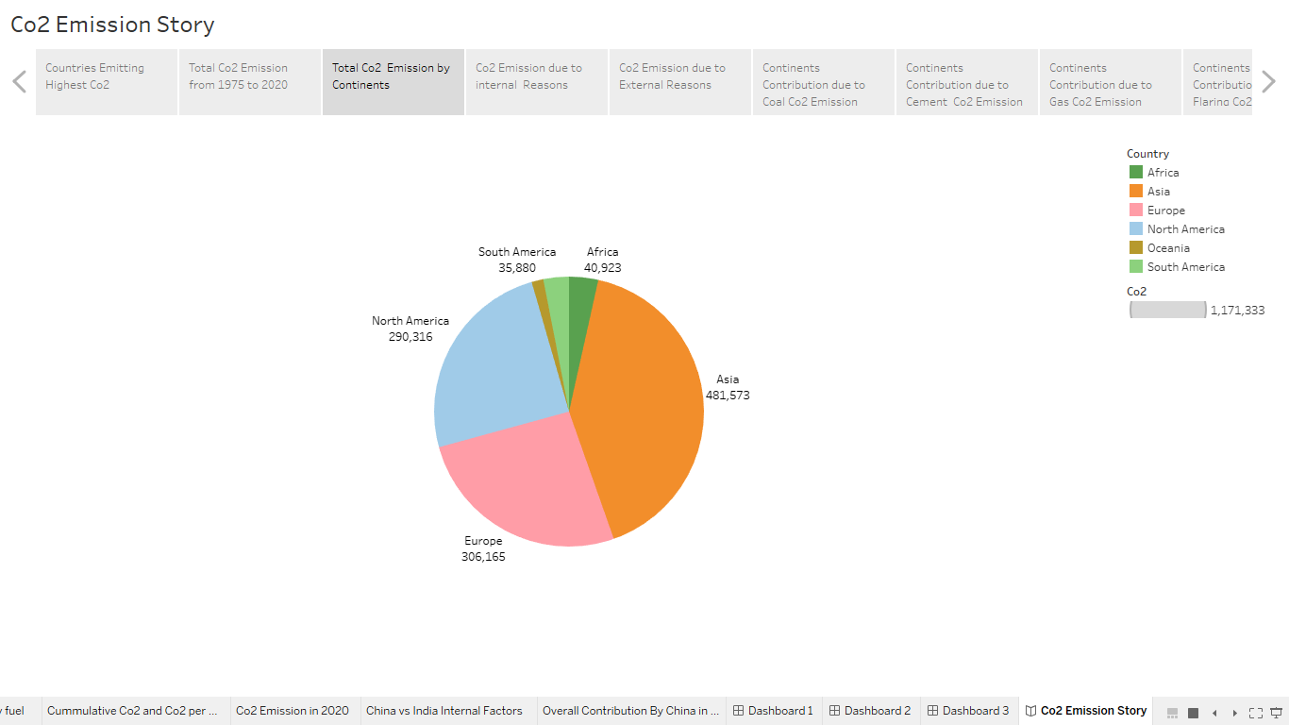

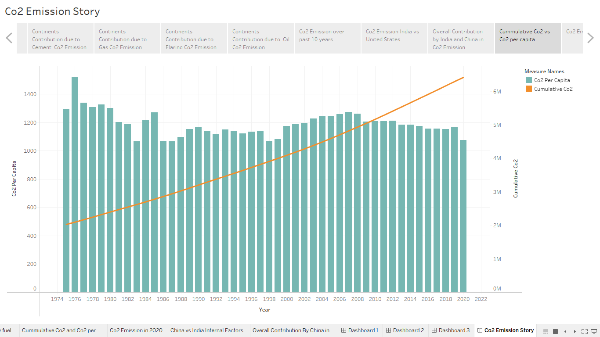

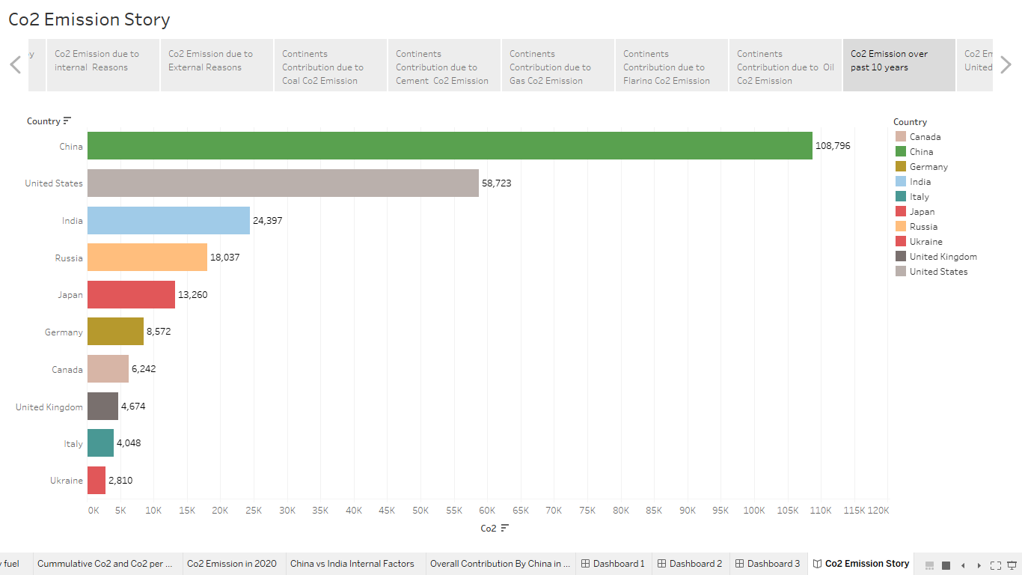

1. **ADVANTAGES & DISADVANTAGES :**
   1. **ADVANTAGES :**

Analyzing global CO2 emissions can provide several advantages in unearthing the environmental impact of human activities. Here are a few advantages:

1. Identifying Major Contributors: By analyzing global CO2 emissions, we can identify the countries, industries, and sectors that are major contributors to carbon emissions. This information can help in developing targeted policies and strategies to reduce emissions.
2. Tracking Progress: Analyzing CO2 emissions over time can help us track progress in reducing emissions. This data can help us evaluate the effectiveness of policies and initiatives aimed at reducing emissions.
3. Encouraging Action: Publicizing data on global CO2 emissions can help raise awareness about the impact of human activities on the environment. This can encourage individuals, organizations, and governments to take action to reduce their carbon footprint.
4. Comparing Across Regions: Analyzing global CO2 emissions can help us compare the environmental impact of different regions and countries. This can provide valuable insights into the environmental practices and policies of different nations and help identify areas where improvements can be made.
5. Supporting Climate Negotiations: Global CO2 emissions data can be used to inform climate negotiations and agreements. This data can help policymakers understand the scale of the problem and develop effective strategies to address it.

Overall, analyzing global CO2 emissions is an important tool in understanding the environmental impact of human activities and developing strategies to reduce emissions and mitigate climate change.

* 1. **DISADVANTAGES**

While analyzing global CO2 emissions can help in identifying the environmental impact of human activities, there are some disadvantages to this approach:

1. Limited focus: Analyzing CO2 emissions alone can limit our understanding of the overall environmental impact of human activities. There are other greenhouse gases, such as methane and nitrous oxide, that also contribute to climate change and need to be considered.
2. Incomplete data: Data on CO2 emissions may be incomplete or inaccurate in certain regions or countries. This can make it challenging to draw accurate conclusions about the environmental impact of human activities.
3. Limited solutions: Focusing solely on CO2 emissions can lead to a limited set of solutions. While reducing CO2 emissions is essential, other solutions, such as reducing resource consumption and waste, protecting biodiversity, and promoting sustainable land use, are also necessary to address the overall environmental impact of human activities.
4. Over-reliance on technology: There is a risk of over-relying on technological solutions to reduce CO2 emissions, such as carbon capture and storage or geoengineering. While these solutions can be useful, they are not a substitute for reducing emissions at the source and changing our behavior as a society.
5. Social and economic impacts: Addressing the environmental impact of human activities also has social and economic impacts, which need to be taken into account. For example, transitioning to renewable energy sources may have economic and social consequences, such as job losses in the fossil fuel industry or changes in the energy prices for consumers. These impacts need to be managed carefully to ensure a just transition to a sustainable future.
6. **APPLICATIONS :**

There are several ways to analyze the environmental impact of human activities, but one of the most common and significant factors is CO2 emissions. CO2 emissions are a major contributor to global warming and climate change, and understanding their sources and patterns can help inform strategies to mitigate their effects.

To conduct a global CO2 emissions analysis, you could use an application that integrates data from various sources, including:

1. National and international greenhouse gas inventories: These inventories track emissions from different sectors, such as energy, transportation, agriculture, and waste, and provide data on the amounts of CO2 and other greenhouse gases emitted by different countries and regions.
2. Satellite imagery and remote sensing: These technologies can provide information on land use changes, deforestation, and other activities that affect carbon sequestration and storage.
3. Industry and corporate data: Many companies now report their greenhouse gas emissions and other environmental impacts, providing valuable insights into the carbon footprint of different sectors and industries.
4. Climate models and projections: These tools can help predict future trends in greenhouse gas emissions and their impact on the climate.

Using these data sources, an application could generate visualizations and analyses that show:

* The total amount of CO2 emissions by country or region, as well as per capita and per GDP.
* The distribution of emissions by sector, such as energy, transportation, and industry.
* Trends in emissions over time, including changes in total emissions and emissions intensity (CO2 per unit of economic activity).
* The impact of different policies and interventions, such as carbon pricing, renewable energy incentives, and energy efficiency measures.
* Projections of future emissions under different scenarios, such as business as usual, ambitious climate action, or technological breakthroughs.

By using a global CO2 emissions analysis application, policymakers, researchers, and the public can gain a better understanding of the environmental impact of human activities and identify opportunities for reducing greenhouse gas emissions and mitigating climate change.

1. **CONCLUSION :**

After conducting a global CO2 emissions analysis, it is clear that human activities have a significant and detrimental impact on the environment. The burning of fossil fuels for energy production and transportation is the leading contributor to CO2 emissions, which trap heat in the atmosphere and lead to global warming and climate change.

Furthermore, deforestation and land-use changes also contribute significantly to CO2 emissions, as trees and plants play a crucial role in absorbing carbon dioxide from the atmosphere. Other human activities such as industrial processes and agriculture also contribute to CO2 emissions.

The consequences of these emissions are severe and far-reaching, including rising sea levels, increased frequency and intensity of natural disasters, loss of biodiversity, and negative impacts on human health.

To mitigate these impacts, it is crucial to take action to reduce global CO2 emissions. This can be achieved through the adoption of cleaner energy sources, such as renewable energy, as well as implementing policies and regulations that encourage sustainable practices and reduce carbon emissions.

It is important for individuals, businesses, and governments to take responsibility for their actions and work together to create a more sustainable future for our planet. Only by taking concerted action can we hope to mitigate the negative impacts of human activities on the environment and preserve our planet for future generations.

1. **FUTURE SCOPE :**

The environmental impact of human activities is a critical issue facing our planet today. Carbon dioxide (CO2) emissions, primarily from burning fossil fuels, are a significant contributor to climate change. A global analysis of CO2 emissions can help us understand the magnitude of the problem and inform strategies to address it.

There are several areas of future research that could help us better understand the environmental impact of human activities and reduce CO2 emissions:

1. Expanding the scope of analysis: While global CO2 emissions are a useful metric, it is important to consider emissions at regional and local scales. This can help identify areas with the highest emissions and inform targeted mitigation strategies.
2. Tracking emissions over time: Monitoring changes in CO2 emissions over time can help identify trends and determine the effectiveness of policies aimed at reducing emissions.
3. Exploring alternative energy sources: Research into renewable energy sources, such as wind, solar, and hydropower, can help identify ways to reduce dependence on fossil fuels.
4. Advancing technology: Developing and implementing new technologies, such as carbon capture and storage, can help mitigate the impact of CO2 emissions from fossil fuel use.
5. Changing behavior: Educating individuals and communities about the impact of their actions on the environment and promoting sustainable practices can help reduce CO2 emissions.

In summary, there is a significant need to continue studying and analyzing global CO2 emissions to better understand the environmental impact of human activities. Future research should focus on expanding the scope of analysis, tracking emissions over time, exploring alternative energy sources, advancing technology, and promoting sustainable behavior. By addressing these areas, we can work towards a more sustainable future and mitigate the impact of human activities on the environment.